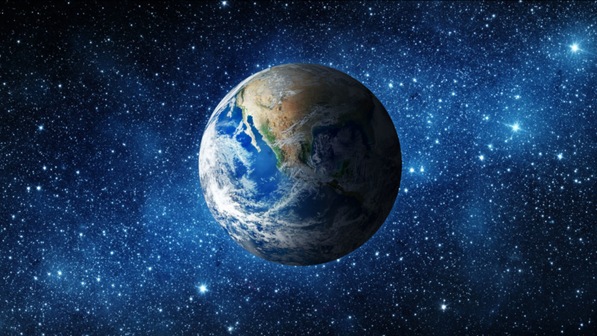

**History**

Learn about how the significant person, Mary Anning changed our understanding of prehistoric animals on planet earth.

Learn about the first man to walk on the moon. Role play being spacemen and what their lives would be like inside a rocket for months.

**Art and D+T** The children will be making their own papier mâché planets to help give them some perspective on the sizes of the planets compared to earth, the moon and the sun.

We will also be baking fossil cookies which links to our History topic about significant people; Mary Anning.

Children will make a collage of our world with a focus on the elements: earth, wind, fire, ice.

They will create a rocket using finger painting.

Make a rocket out of a cardboard box and link to Science (Everyday Materials).

Create planets using crumpets as sponges.

**Our Amazing Planet**

**School trip!** TheHorse Chestnut Class are going to Jodrell Bank to see the wonders of the universe! This is on 22nd March 2024. There is more information on our trip letter!

**Computing** The children will have a go at making a space themed picture using power point and learn how to safely turn on, switch off and save their work in a folder.

**Spellings –** The children will continue to practise their statutory year 1 and 2 spellings. They will still be taking them home to learn, however we will not be doing a weekly test, they will just write them in a sentence dictated by the teacher every Wednesday. We will also do a big revision of all of their new words each half term.

**Geography** The children will be understanding that the world is spherical.

The Horse Chestnuts will be using maps and atlases to explore the human and physical features of the places on our planet, in particular in our local area.

**Music** We will listen to various space themed musical pieces to help us create a piece of music using musical instruments of what it might sound like as we embark on a journey into space.

**English** The children will create a passport to go to space! We will role play getting in our spaceships and travelling through space. They will be looking at acrostic poems and writing their own rocket themed one. Through our study of our planet and space, the children will also design and create an encyclopaedia page and a non chronological report using a fact book called ‘Our Amazing Planet’. They will also write question sentences to ask on our trip, as well as write a diary recount about their own personal experiences from their day at Jodrell Bank. They will also be writing a postcard to an alien about what it is like to be in space as well as describing the alien they may have encountered on an imaginary trip to space.

**Science** In line with the National Curriculum, will look at *seasonal changes* which tell winter is now changing to spring. We will also be touching on some everyday materials and exploring which ones would make an effective rocket!

We will explore our solar system and our planet which co-insides with our trip to Jodrell Bank

**PE –** The children will perform dances using simple movement patterns. They will also have a go at doing some moonwalking or walking around pretending you are a spaceman with no gravity holding you down to some super space music.

**Welcome to the new Term!**

This term is all about exploring our amazing planet! This will largely be exploring space, the solar system and lots of facts about things that happen on our own planet.

The children will be immersed in various planet and space based educational activities from identifying different light sources such as the sun and investigating shadows, to learning about the first man on the moon and how the lives of significant people have contributed to international achievements.

**Our amazing planet**