Dear parents and carers,
Your child is in the ‘Stars’ spelling group. They will receive a list of spelling words on a Friday to practise throughout the week ready for a test on the following Friday.
Please can you support your child with their spellings by encouraging them to practise as much as they can throughout the week at home.
This booklet contains their spelling lists for each week of the second Autumn term. Your child should complete the spelling grid throughout the week as well as the spelling activity. You can also access the spelling lists on the class webpage.
There are lots of creative ways to help your child learn their spellings (see the inside cover) and your child also has an Edshed login to practise their spellings online. Please see the back of the booklet for more information about Edshed.
If you have any questions, please don't hesitate to get in touch.
Thank you,
Mrs Downings

Date of spellings introduced in school | Spelling Rule | Test date
10.11.23 | Words where ‘wr’ makes a /r/ sound at the beginning of words | 17.11.23
17.11.23 | Words ending in ‘le’ | 24.11.23
24.11.23 | Words ending in ‘el’ | 01.12.23
01.12.23 | Words ending in ‘al’ | 08.12.23
08.12.23 | Words ending in ‘il’ | 15.12.23
15.12.23 | Challenge words | 21.12.23*

Please send this booklet (completed) back into school on Thursday 21st December.
*Not in school on Friday 22nd December so their spelling test will be brought forward to the 21st.

Spelling activities
- Write your spelling words in alphabetical order.
- Make a set of flashcards for practising your words.
- Write each spelling word three times.
- Write each spelling word in a rainbow of colours. First, write the words with a red crayon. Trace over the words with a blue crayon. Finally, trace the words again with a green crayon.
- Write your spelling words on cards (make two sets) and play "Memory Match" with them against a sibling or parent.
- Write a mnemonic sentence to help you remember each of your spelling words. Each letter of the word should start a word in the sentence. For example, a mnemonic sentence for the word throw might be Ted has rented one wheelbarrow.
- Cut out letters from headlines in newspapers or magazines. Use the letters to spell your spelling words. Paste the letters on paper.
- Write a rap song using all of your spelling words.
- Finger Tracing - Use your finger to spell out each of your words, one letter at a time, on somebody else’s back. Then it’s YOUR turn to feel and spell.
Have fun with your spellings!

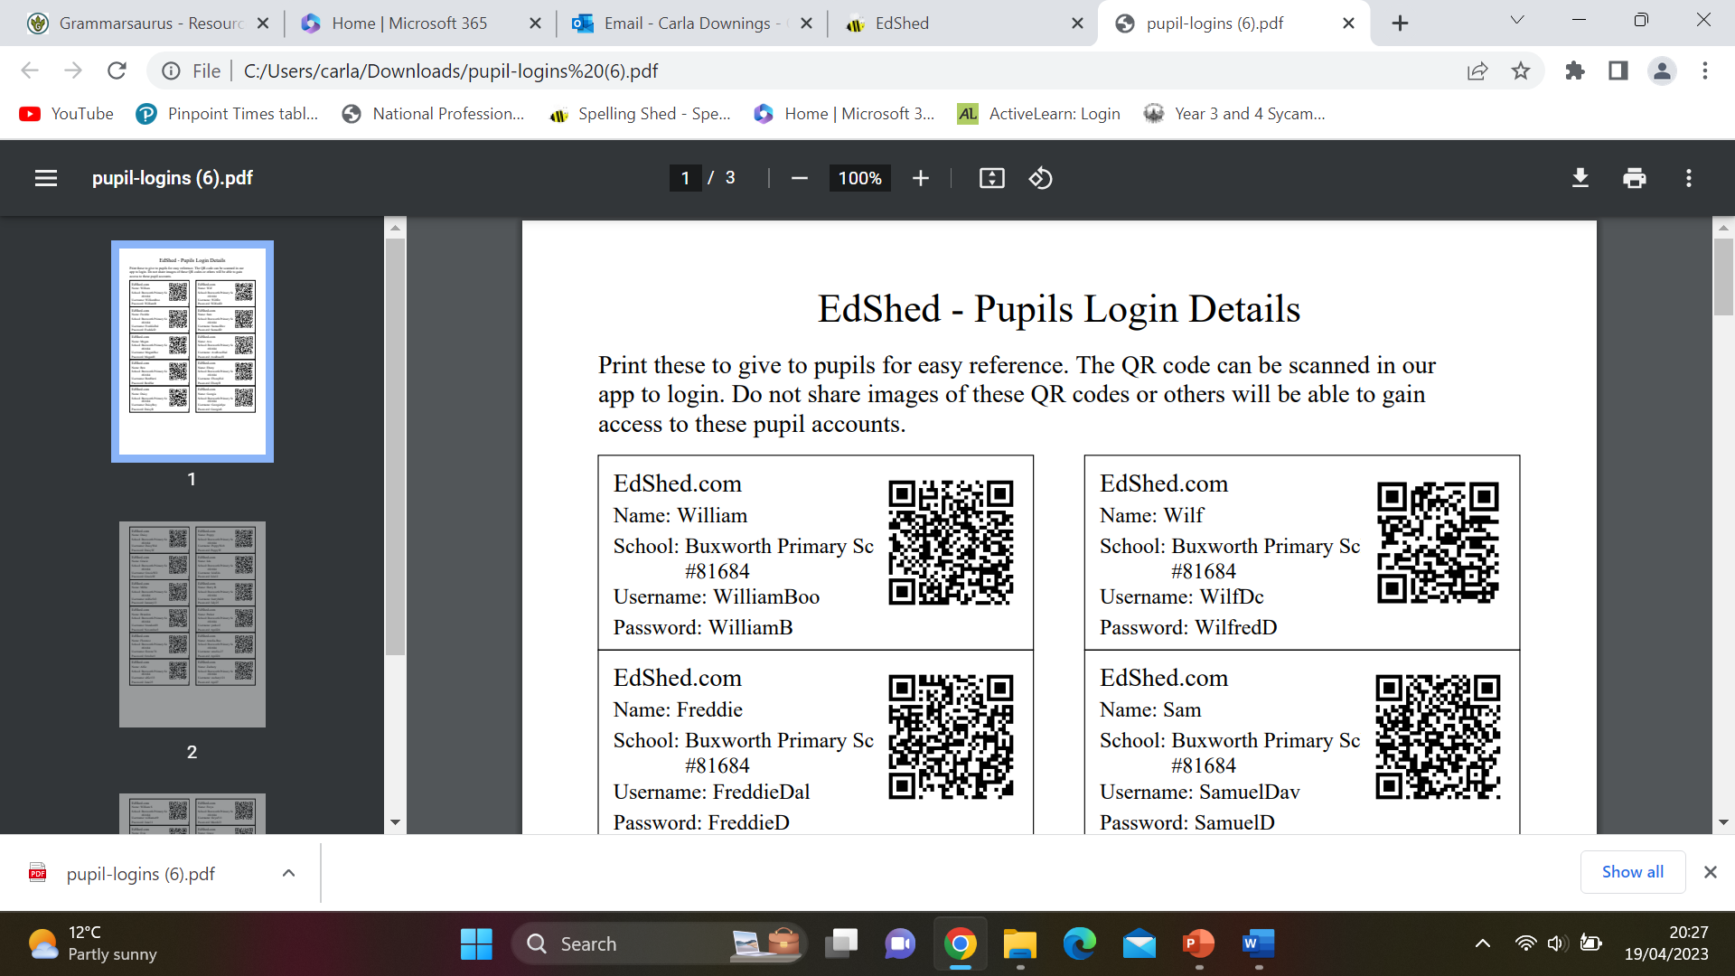
Edshed login details:
https://www.edshed.com/en-gb/login
Username:
Password:

