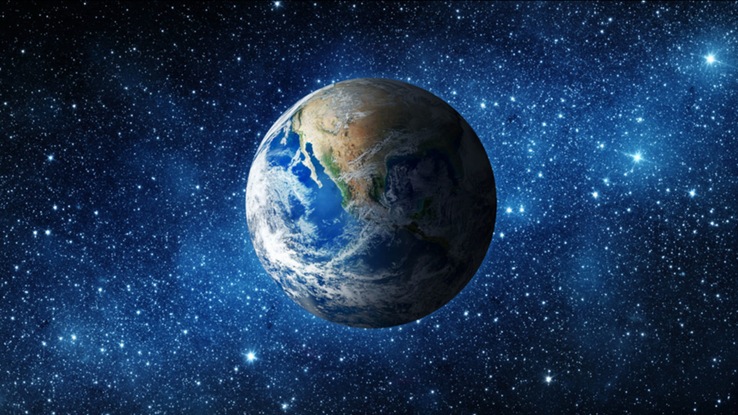

**Literacy** We will be reading and exploring the settings and characters of many of the tradition tales such as ‘The Billy Goats Gruff’, ‘Goldilocks’, and ‘Jack and the Beanstalk’ including acting and filming this story in the woods; making the story come to life. They will also be designing a travel brochure, choosing a continent to research to try to persuade people to visit! Through our study of plants and animals the children will also design and create an encyclopaedia page. They will also write questions to ask our local vicar why is church a special place for Christians?

**Music** We will listen to ‘Carnival of the Animals’ and ask what animals did this music make you think of?

**Art and D+T** The children will be making their own papier mache globes to help them develop global awareness.

We will also be making our own fossils using modelling clay, pasta, shells and glue. We will also be baking fossil cookies!

Children will make a collage of our world with a focus on the elements: earth, wind, fire, ice.

The children will create their own artwork and poetry through the theme of ‘Earth Day’. This includes a tree shape painting, tints and shades painting, researching a photo of a fossil and presenting their work as a final piece.

**History** Children will research fossils and animals that are no longer alive. We will handle a fossil and talk about what it can tell us. We will also learn about how someone finding fossils such as Mary Anning changed our understanding of prehistoric animals. We will also be role playing being archaeologists!

**Maths** Ordinal numbers and days of the week: children will retell which events happened in the creation story using ordinal numbers and the days of the week. They will look at using standard and non-standard measures of size and weight. We will ask and find out how fast your animal moves, how long it lives and how many eggs it lays.

**Science** We will look at *seasonal changes* and clues which tell winter is changing to spring.

We will also learn about what living things need to survive and how to label the plants around us. The children will plant a ‘magic’ bean based on Jack and the Beanstalk and watch it grow. They will learn about what it needs to survive.

**RE and British Values** The children will be exploring different places of worship. They will look at special places in different religions and discuss a place that is special to them. We will ask what happens in a mosque, gurdwara and Buddhist temple. We will think about why they are important. Finally they will design a non religious special place.

**Computing** children will learn how toswitch on and shut down, use a mouse, save in a folder and drag documents !

**Our Amazing Planet**

**Geography** Children will be understanding that the world is spherical and creating their own journeys across the world.

The Horse Chestnuts will be using maps and atlases to explore the human and physical features of the places in our local area. They will be comparing them with North and South America and Europe.

**Welcome to the new Term!**

This term is all about exploring our amazing planet, from weather watching where children will be filming their own weather forecasts, to retelling and filming the story of ‘The Billy Goats Gruff’ in our woodland area to finally baking fossil cookies and writing our own recipes!

**Our amazing planet**