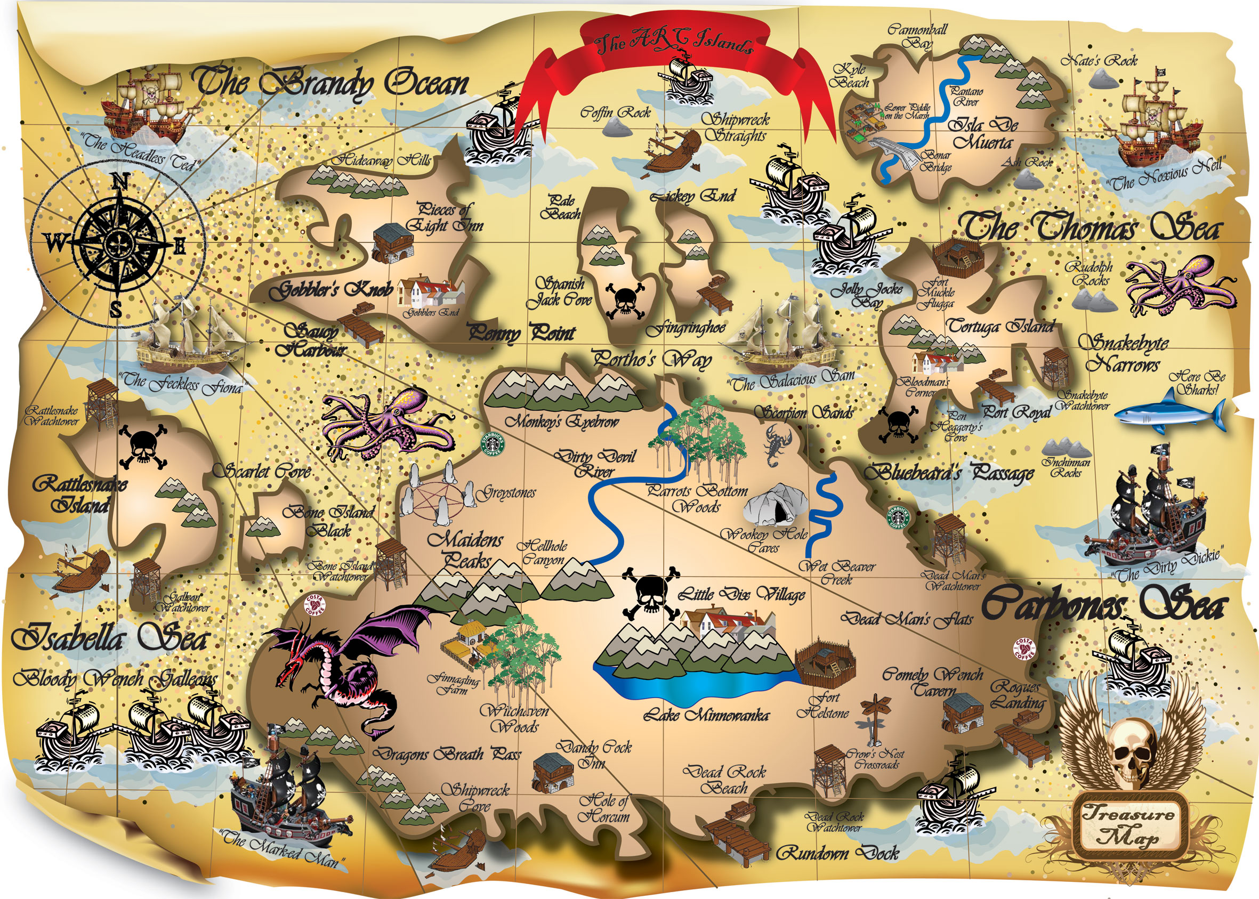

**Pirates**

Literacy The children will imagine being marooned on a desert island and write a message for help which we will put inside a bottle. We will also look at the roles on a pirate ship to then apply for a job working on board. Throughout the term, we will be creating pirate artefacts to go inside our pirate museum; the children will be writing invitations and designing adverts to invite other classes to our pirate museum.

Maths – The children will be continuing with their power maths scheme; giving them a mastery approach to problem solving. We will also be plotting hidden treasure using a co-ordinates grid for another child to find.

British Citizenship– We will discuss the roles of women as piratesaround the worldand the definition of equality between men and women. We will ask the children if men and women can do the same job?

British values **:** we will find out all about China, comparing its climate, location, culture and how our schools are different and similar to that in the UK.

Buxworth Values: The children will use their **entrepreneurial** skills to create and run their pirate museum, as well as make and sell refreshments. We will also look at having **compassion** for our fellow shipmates.

Science The children will look at ‘animals including humans’ including categorising animals and identifying carnivores and herbivores.

We will also look at diet and what our bodies need and compare this with a pirate’s diet; why they got scurvy.

Music The children will listen to and learn sea shanties.

Geography We will draw a key and treasure map, hiding real treasure around forest schools for other pirate children to discover. We will also look at the obstacles they might overcome such as forest, desert, quick sand, caves and lakes.

We will also be using maps and atlases to locate the 4 counties in the UK as well as naming and labelling the 7 continents and 5 oceans, and exploring and comparing China.

Welcome to the new term!

Ahoy there! To conclude our final few weeks of the summer term we thought we would all become pirates! The children will be creating artefacts and showcasing them to their fellow classes as well as making their own pirate food and drinks to ‘sell’; continuing with our Project 25 scheme.

The Arts The children will design their own pirate flag and then make it using fabric cloth and textile paints.

We will have a go at drawing ourselves as a pirate after drawing our own alto ego pirates.

History We will be learning about what life was like in the past by looking at real, local pirates. The children will research the infamous Blackbeard as well as Anne Bonney and make an information booklet about them for our pirate museum.

Pirates